**Department of Computer Science & Engineering**

**Final Year B. Tech. (CSE) – I : 2023-24**

**5CS462 : PE5 - Data Mining Lab**

**Assignment No. 6**

Use / extend the data analysis tool (menu driven GUI) developed in Assignment No. 1

to perform the following task :

1. Design and implement the following clustering algorithm:

1. Hierarchical clustering - AGNES & DIANA. Plot Dendrogram.
2. k-Means
3. k-Medoids (PAM)
4. BIRCH
5. DBSCAN

2. Tabulate the results with cluster validation accuracy

3. Use the following data sets from UCI machine learning repository :

1. IRIS
2. Breast Cancer
3. For BIRCH / DBSCAN, use US Census Data (1990) Data Set

<https://archive.ics.uci.edu/ml/datasets/US+Census+Data+(1990)>

**KMeans**

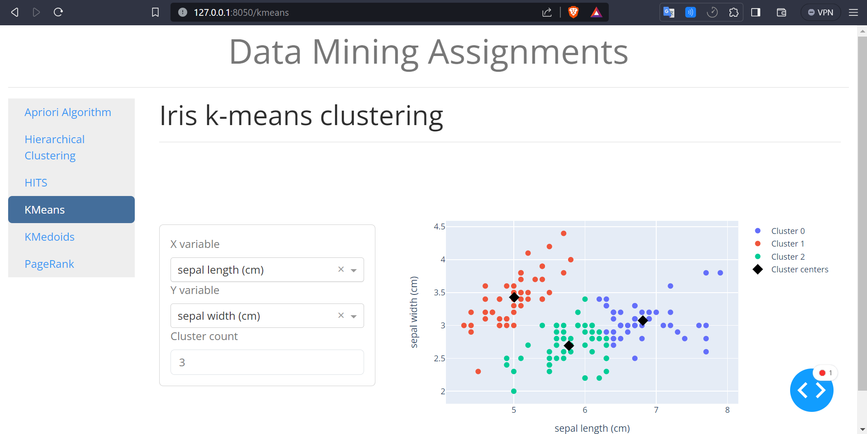

**Select Attribute**

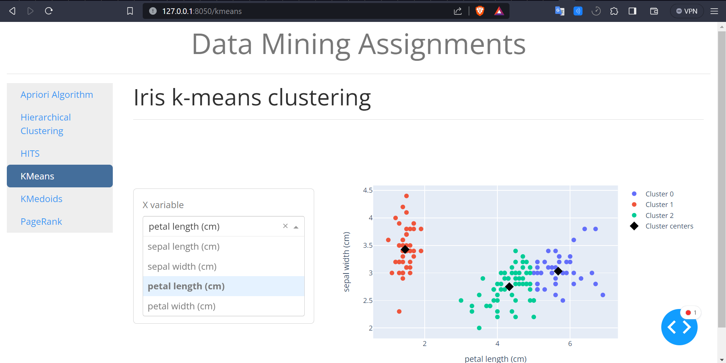

**Can Change No. of Clusters**

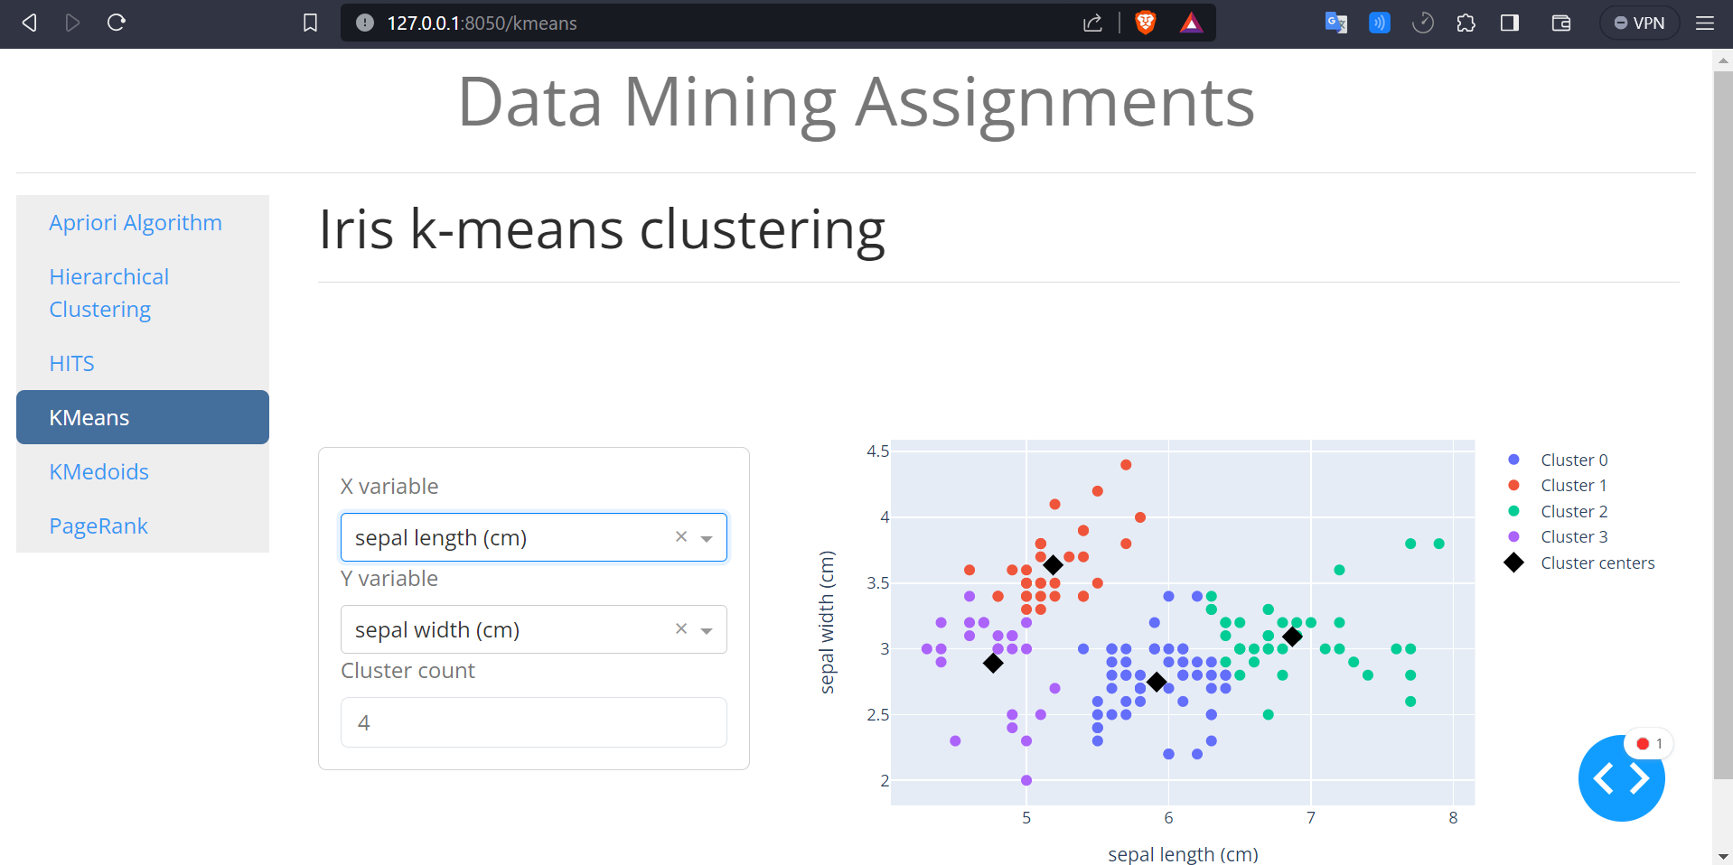

**Interactive Plot**

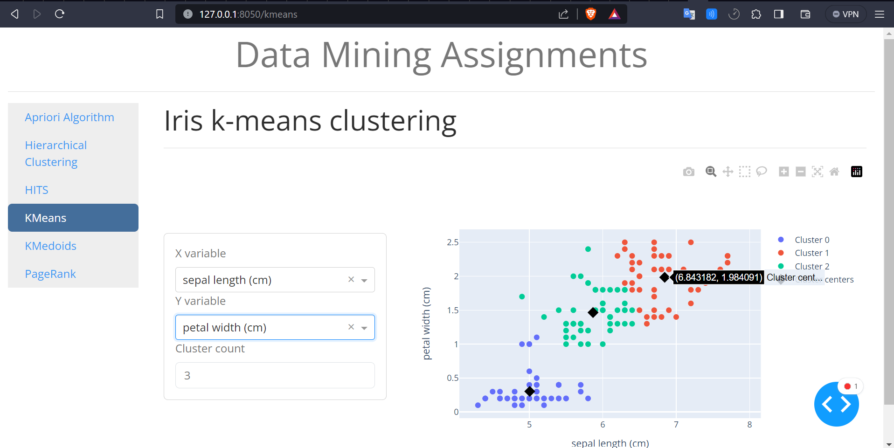

**KMedoid**

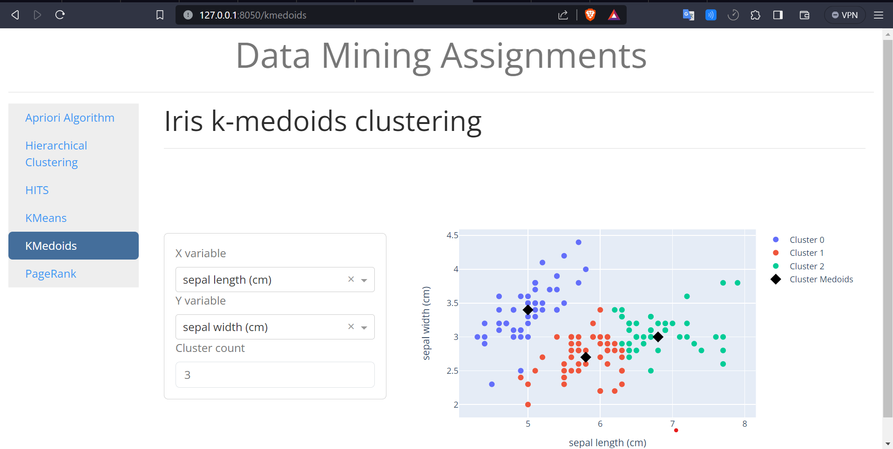

**Select Attribute**

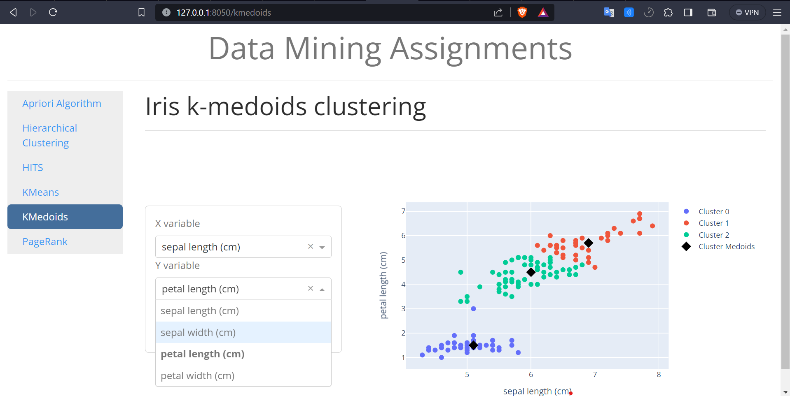

**Can Change No. of Clusters**

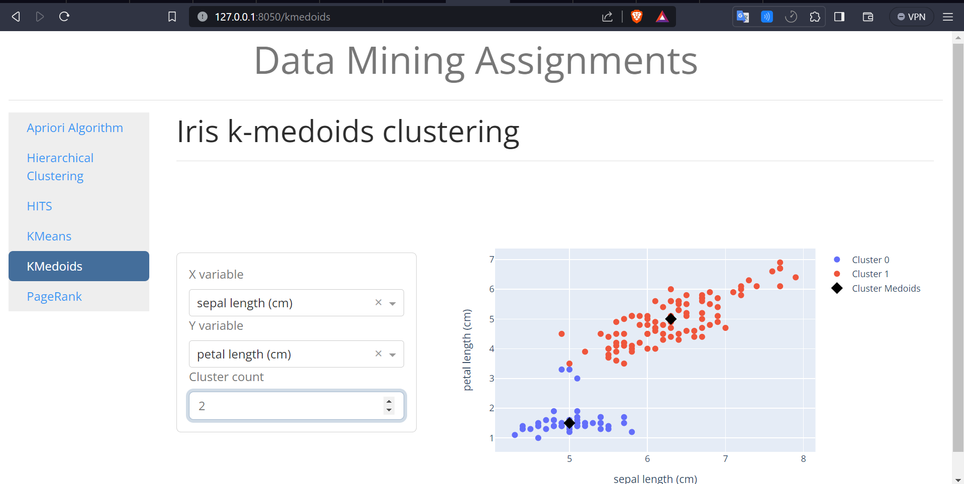

**Interactive Plot**



**DBSCAN**

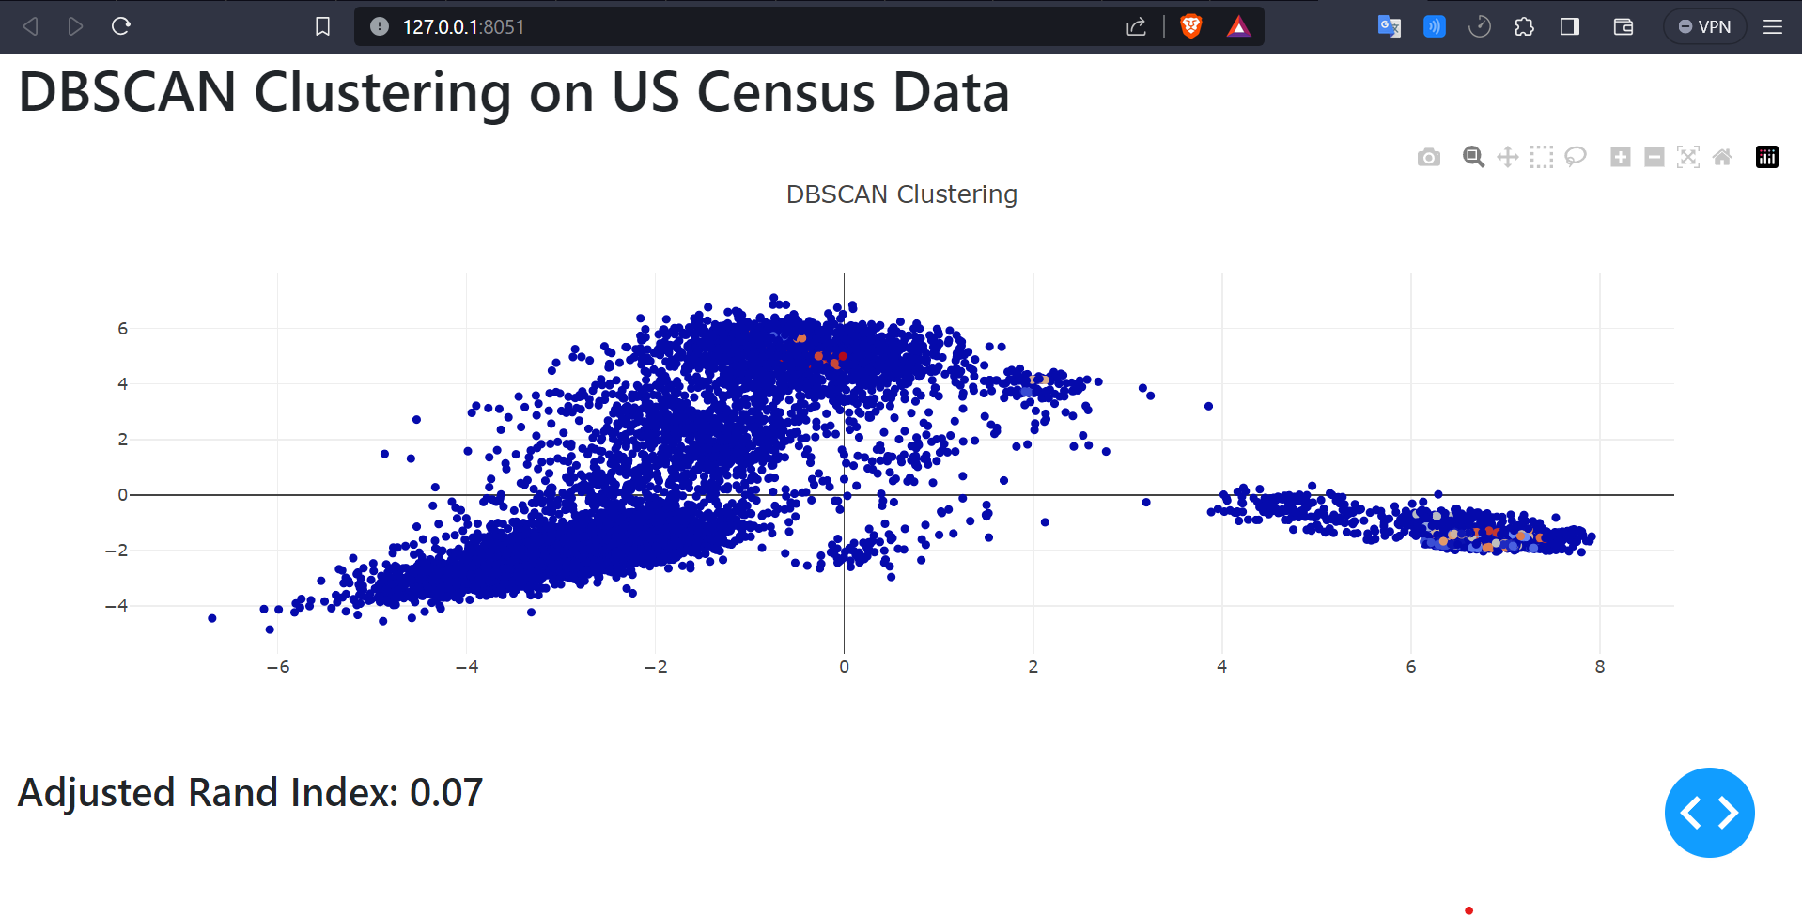

**BIRCH**

